- OBJECTIVE AND SCOPE

Incident Reporting is one of a number of health and safety standards forming the Trust’s Health and Safety Policy written arrangements in compliance with the general duties under Section 2 of the Health and Safety at Work etc. Act 1974.

This standard relates specifically to the monitoring of incidents and near misses with particular emphasis on the Reporting of Injuries, Diseases and Dangerous Occurrences (RIDDOR) Regulations 2013 , The Social Security (Claims and Payments) Regulations 1979 and the Social Security Administration Act 1992

- RESPONSIBILITY

Overall responsibility for standard belongs to the Chief Officer, Executive Leads, Strategic Leads and the Council’s Health and Safety Manager.

The Extended Management Team, Development Co-ordinators and the Council’s Health and Safety Section are responsible for ensuring that the incident reporting procedures are fully implemented within their areas of control.

All Trust employees have a responsibility to ensure that they report all incidents and near misses which occur in the workplace.
AUTHORISED BY: Chief Officer
DATE: February 2024
CONTENTS

1. INTRODUCTION 2
2. REPORTING REQUIREMENTS UNDER RIDDOR 2
2.1 Riddor Requirements 2
2.2 Fatalities 2
2.3 Self-Harm 3
2.4 Specified (Major) Injuries 3
2.5 non-Employee injuries 4
2.6 Over Seven Day Injuries to Employees 4
2.7 Definitition of Work Related incidents 4
2.8 Reportable Dangerous Occurrences 5
2.9 Reportable Diseases/Work Related Illnesses 5
2.10 Reportable Gas Incidents 6
3. RECORDING NON RIDDOR REPORTABLE INCIDENTS 6
31 Introduction 6
3.2 Non-Sepcified injuries to Employees 6
3.3 Minor injuries To Non-Employees 6
3.4 Incidents of Fire 7
3.5 Near Miss Incidents 7
3.6 Needle Finds 8
3.7 Incidents of Violence and Agression 8
3.8 Stress 8
4. Recording Incidents On SHE 9
4.1 Reporting Using the SHE System 9
4.2 BI 510 – Accident Book Entries For Employee Incidents 10
4.3 Accident Investigations 10
5. summary 11
6. FURTHER INFORMATION 11

Appendix 1 – Action to take in the Event of a Serious Incident
Appendix 2 – Incident Investigation Report Template
Appendix 3 – Incident Investigation Process
Appendix 4 – Incident Debrief Guide for Managers – Violence and Aggression

1. INTRODUCTION
1.1 The Trust’s Incident Reporting standard has been implemented to ensure continued compliance with legal requirements under duties of:

- Reporting of Injuries Diseases and Dangerous Occurrences Regulations (RIDDOR) 2013
- Social Security (Claims and Payments) Regulations 1979
- Social Security Administration Act 1992

1.2 The procedures detailed in this standard must be followed in the event of any incident which occurs in premises under the control or supervision of the Trust or as a result of Trust activities involving employees, contractors, service users or members of the public.

1.3 Statutory notification to the Health and Safety Executive (HSE) of incidents which fall under the scope of RIDDOR is the responsibility of the Council’s Health and Safety Manager who will ensure RIDDOR reports are completed on behalf of all Trust departments.

1.4 This Standard also provides an overview of SHE, which is the incident reporting and management system used for reporting incidents internally within the Trust.

1.5 Under Social Security legislation, there is a further requirement to make sure that an employee is able to demonstrate that their employer was informed of any work related incident; should there be a need to claim benefit as a result of any absence from work. This can be achieved by recording the details of the incident on the SHE system.

2. REPORTING REQUIREMENTS UNDER RIDDOR

2.1 RIDDOR requirements

Under the requirements of RIDDOR, there are certain types of incidents which must be reported to the Health and Safety Executive (HSE) by law.

The Council’s Health and Safety Manager is responsible for reporting any RIDDOR incidents to the HSE within specified timescales.

In order that specified timescales are achieved, managers must ensure that all incidents are reported on the SHE system promptly and Senior Management and the Council’s Health and Safety Manager notified immediately by telephone in the event of a serious incident. See Appendix 1 for further detail on action to take in the event of a serious incident.

2.2 Fatalities

The death of any person, employee or non-employee, resulting from an accident arising out of or in connection with work, must be reported to Senior Management and the Council’s Health and Safety Manager immediately. This includes where a fatality has been caused by an act of physical violence towards an employee.

There is a further requirement to report the subsequent death of an employee who dies as the result of a reportable injury within one year of the date in which the incident occurred.

Managers must ensure the progress of any employee who is seriously injured in a workplace incident or is diagnosed with work related disease/ illness is carefully monitored, including where the employee no longer works for the Trust. Senior Management and the Council’s Health and Safety Manager must be notified immediately of the subsequent death of an employee in circumstances outlined above.

2.3 Self-Harm

Acts of deliberate self-harm, including suicide, by employees, or service users are not considered to be “accidents” and therefore are not reportable under RIDDOR and do not require to be recorded on the SHE system, unless agreed in advance with the Council’s Health and Safety Manager.

Acts of deliberate self-harm are considered to be significant events and all services must have suitable internal reporting processes in place to ensure that acts of self-harm are recorded and investigated.

Whilst there is no requirement to report acts of deliberate self-harm under RIDDOR, there may be circumstances where such acts are investigated by the regulatory authorities, including the Health and Safety Executive (HSE), where it is considered by the relevant authority that management failure has been a contributory factor.

2.4 Specified (major) injuries

Where a specified injury is sustained by an employee or non-employee, a Senior Manager and Council’s Health and Safety Manager must be notified immediately and the incident recorded on SHE as detailed in 4.1.

Under RIDDOR 2013, specified injuries are defined as follows:
    - The fracture of any bone other than the fingers, thumbs or toes (note chipped bones are regarded as fractures for the purposes of RIDDOR)
    - Amputation of an arm, hand, finger, thumb, leg, foot or toe
    - Crush injuries leading to internal organ damage
    - Serious burns (covering more than 10% of the body, or damaging the eyes, respiratory system or other vital organs)
    - Scalping (separation of skin from the head) which requires hospital treatment
    - Unconsciousness caused by head injuries or asphyxia
    - Any other injury arising from working in an enclosed space, which leads to hypothermia, heat-induced illness or requires resuscitation, or admittance to hospital for more than 24 hours

2.5 Non-employee Injuries

Where an injury to a non-employee has occurred within premises under the control or supervision of the Trust or, as a result of Trust activities resulting in the injured person being transported from the scene of the incident to hospital for treatment, this may be reportable under RIDDOR.

The responsible manager/development officer should ensure the incident is logged on the SHE system within five working days.

2.6 Over seven day injuries to employees

Where an employee is incapacitated as a result of a work related incident for more than seven consecutive days the incident becomes reportable under RIDDOR. This does not include injuries which fall under the “specified” category, which are immediately reportable as detailed in 2.4.

Records must be kept of all incidents where the employee has been incapacitated for seven or fewer consecutive days but these are not reportable to the HSE.

Incapacitation means that the employee is absent from work or is unable to carry out the duties that they would reasonably be expected to do as part of their normal working day.

The day the incident occurred is not included in the seven days but weekends and rest days are. RIDDOR reports must be made to the HSE within 15 days of the accident.

The SHE system must be updated with details of any employee’s absence due to a work related incident. Details on how to update and manage SHE records can be found at SHE user guide for Managers.

Updating the incident severity to a different RAG (red, amber, green) rating category will automatically generate an email which will be sent to Health and Safety and the relevant manager. This will allow any subsequent RIDDOR reports to HSE to be made within the specified timescales.

2.7 Definition of work related incidents

For an employee incident to be reportable under RIDDOR, it must have occurred at or in connection with work.

Incidents sustained during unpaid lunch or shift breaks are not classified as ‘at work’.

Incidents at work do not include time when an employee is travelling to or from work unless they are travelling in a Trust vehicle or are being paid expenses for the journey to their first appointment.

Road traffic accidents, in general terms, do not need to be reported under RIDDOR unless the accident involved:
- The loading or unloading of a vehicle
- Work alongside the road e.g. construction or maintenance work
- The escape of a substance being transported by a vehicle
- A train

2.8 Reportable dangerous occurrences

Dangerous occurrences are certain specified near miss events which have the potential to cause major injury or death. There are a total of twenty seven categories, however some specified dangerous occurrences applicable to most workplaces include:

- The collapse, overturning or failure of load bearing parts of lifts or lifting equipment
- Plant or equipment coming into contact with overhead power lines
- Explosions or fires causing work to be stopped for more than 24 hours

The full list of specified dangerous occurrences is available in Schedule 2 of RIDDOR.

Dangerous occurrences must be reported immediately to Senior Management and the Council’s Health and Safety Manager and the incident logged on SHE as detailed in 4.1.

Where an injury occurs and is reportable under one of the other categories of RIDDOR i.e. a specified injury, the dangerous occurrence should not be reported separately. If however, the injury is not reportable under RIDDOR or no injury has been sustained; the incident should be reported as a dangerous occurrence.

The Council’s Health and Safety Manager will ensure all incidents of dangerous occurrence are reported to the HSE as specified under RIDDOR.

Managers are advised that where they are unclear regarding categories of dangerous occurrences they should contact the Council’s Health and Safety Team prior to completing the SHE report, for further advice.

2.9 Reportable diseases/ work related illnesses

Reportable employee diseases or illnesses are conditions which have been caused or made worse by conditions relating to work.

Under Regulations 8 and 9 of RIDDOR 2013 the diseases/ work related illnesses which must be reported to HSE are: -
- Carpal tunnel syndrome
- Severe cramp of the hand or forearm
- Occupational dermatitis
- Hand-arm vibration syndrome
- Occupational asthma
- Tendonitis or tenosynovitis of the hand or forearm
- Any occupational cancer
- Any disease attributable to an occupational exposure to a biological agent, including COVID-19

For these conditions to be reportable under RIDDOR, they must have occurred as a result of employment with the Trust.

It is most likely that conditions will be identified as a result of Trust health surveillance programmes but may also have been identified initially through an employee’s own doctor.

Where certain conditions are identified by a doctor, the manager should make a referral to Occupational Health who will carry out a formal assessment of the disease/ illness to confirm whether or not it is reportable under the requirements of RIDDOR.

Reportable diseases should be recorded on the SHE system as in 4.1. All correspondence and information of the disease or condition must be kept in the employee’s medical file for a minimum of 40 years.

Where cases of reportable diseases/ illnesses are confirmed as being related to work activities, Occupational Health will notify the employee’s line manager and the Council’s Health and Safety Manager who will ensure the appropriate reporting procedures are followed as specified under RIDDOR.

Further information and guidance is available from Occupational Health or the Health and Safety Strategy Group.

2.10 Reportable gas incidents

RIDDOR 2013 requires that gas engineers registered with the Gas Safe Register must provide details of any gas appliance or fittings which they consider to be dangerous to the extent that people could die, lose consciousness or require hospital treatment. This may arise from:
- An accidental leakage of gas
- Inadequate combustion of gas
- Inadequate removal of products of the combustion of gas.
Reportable gas incidents, which do not result in injury, should be recorded as a near miss using the SHE system as detailed in 4.1 and the Health and Safety team will liaise with the responsible engineer to ensure they are reported to the HSE as required under RIDDOR.

3. RECORDING NON RIDDOR REPORTABLE INCIDENTS

3.1 Introduction

Most incidents which do not fall into any of the categories required under RIDDOR must still be recorded on the Trust’s incident reporting system (SHE).

3.2 Non-specified injuries to employees

Where an employee sustains an injury which does not fall under the specified list above i.e. is more minor in nature, it must be logged as soon as possible using the SHE system as detailed in 4.1.

Incidents must be logged on the SHE system within a maximum of five working days of the incident.

3.3 Minor injuries to non-employees

Where a non-employee i.e. service user, resident, contractor, pupil or a member of the public sustains a minor injury (not requiring hospital treatment) as a result of Trust activities or within premises under the control or supervision of the Trust, the incident must be logged as soon as possible using the SHE system as detailed in 4.1.

As with non-specified incidents to employees, they must be logged on the SHE system within a maximum of five working days of the incident.

3.4 Incidents of fire

All cases of fire, no matter how small and irrespective of whether Fire and Rescue Service attends the site, must be reported using the SHE system as detailed in 4.1.

Unless the fire is classified as a Dangerous Occurrence, as outlined in 2.8, it is not reportable under the requirements of RIDDOR.

3.5 Near miss incidents

A near miss is an incident which had the potential to cause injury to a person, or damage to property but does not result in actual injury or damage.

It is important for managers to record near misses as it will help to identify areas of risk and implement further control measures to prevent any reoccurrence, eliminating or minimising the risk of future injury or damage.

All near misses must be reported using the SHE system as detailed in 4.1.

3.6 Needle finds

Cases of unexpected needle finds and needle stick injuries should be recorded using the SHE system as detailed in 4.1.

Where an employee can clearly see a needle(s) and has the training and equipment to remove it safely, a near miss report on SHE is not required. However, where a needle is found unexpectedly during the course of work and there was potential to cause injury, it should be recorded as a near miss.

Whenever there is contact with a needle which results in a needle stick injury it should be recorded as an accident on SHE.

3.7 Incidents of violence and aggression

Where an employee feels threatened, is abused or assaulted the incident should be recorded on the SHE system as detailed in 4.1.

Acts of violence which occur directly between members of the public, pupils or service users do not require to be reported on SHE, where there has been no employee involvement. However, services may still be required to record these types of incidents for example, SEEMIS or as a pastoral note within Education, or for more serious incidents by reporting to the Police.

An incident of violence or aggression may become reportable under the requirements of RIDDOR where an employee is incapacitated for work for more than seven consecutive days or sustains a specified injury as detailed in 2.4.

An incident debrief guide (Appendix 4) has been created to assist managers in investigating and monitoring incidents of violence and aggression.

3.8 Stress

Stress is not reportable as an occupational injury on the SHE system, or under RIDDOR, even when accompanied by a medical certificate stating it is work- related, as it does not arise from a single definable accident.

See Supporting Wellbeing standard for further information on the management of stress in the workplace.

4. RECORDING INCIDENTS ON SHE

4.1 Reporting using the SHE system

The SHE system is used to record and analyse incidents including generating management reports and identifying incident trends.
SHE is used to record the following incidents:
    - All incidents resulting in injury
    - Dangerous occurrences
    - Fire
    - Near misses
    - Incidents of violence and aggression
    - Incidents of self-harm (as per 2.3)

The system can be accessed through the following web addresses: Portal: https://app.uk.sheassure.net/ea/p/portal/

Main system: https://uk.sheassure.net/ea

Employees can record incidents via the portal page, which can only be accessed from a computer or device which is connected to the Trust network.

An e-learning module for inputters has been developed and is available via Learn-Pro and should be completed by employees prior to recording an incident. Any issues accessing the module should be reported to the Council’s Organisational Development.

All managers are encouraged to register for a manager’s SHE account, this will enable them to keep track of reported incidents and allow the Council’s Health & Safety team to contact the correct manager should additional information be required.

In order to register for a manager’s account they should email their name, username, section and line manager to healtyandsafety@east-ayrshire.gov.uk. Managers should refer to the user guide to navigate the system and contact H&S if further guidance is needed.

The incident form is made up of a series of questions which have been divided into the following sections, all fields with a star must be completed:
    - Org Unit (Section)
    - About the incident
    - Who was involved?
    - What happened?
    - Injury details
    - Injury classification
    - Details of any witnesses or assailants
    - Was any equipment involved?
    - Investigation
    - Attachments

Once all fields are complete the details must be saved, which will send the incident to the portal queue for processing. Once processed, emails will be generated notifying the responsible Manager/Development Officer and the Council’s Health and Safety Team that an incident has occurred.

Managers/Development Officers and the Council’s Health and Safety Team can log into the system and view the details of recorded incidents and run reports which can be utilised to identify trends and monitor incident statistics.

Managers/Development Officers will also be able to update incident details and recommend where further actions are required, assigning actions to individuals or groups.

Where actions have been assigned, the responsible person/ group must complete the action on the system. Once an action has been completed the person assigning it must approve the action, if they are satisfied it has been completed.

SHE User Guides have been developed to provide detailed step by step guidance and should be used in conjunction with this standard and are available at: SHE Incident Reporting

4.2 BI 510 – Accident book entries for employee incidents
Records of employee incidents, which have been recorded in the BI 510 accident book prior to the implementation of SHE, should be retained for a minimum of five years from the date of entry.
All BI 510 records must be held securely, and destroyed as necessary, to comply with GDPR requirements.

4.3 Accident investigations

Thorough investigation of work related incidents and near misses is an essential part of managing health and safety; when the causes of incidents are understood, measures can be put in place to prevent or reduce the risk of similar incidents happening again.

The level of investigation will be determined either by the severity of an incident and the circumstances surrounding it or by the potential consequences and likelihood of an unsafe condition being realised e.g. a hazard with the potential to cause serious harm to multiple people.
Investigations will be carried out by either by a member of the health and safety section or by the Trust’s investigation team, often with the involvement of others such as supervisors or union safety representatives.

Regardless of who carries out the investigation, it is essential that managers always gather as much detailed information as possible immediately following any incident or after being made aware of an unsafe condition. It is also important that any evidence at the incident scene is preserved where possible and photographs/ video of the incident site are taken.

In most cases investigations needn’t be complex or time consuming; for example, if an employee trips and falls then it should be sufficient to interview the employee involved and any witnesses and visit the area where the incident occurred to look for possible trip hazards. Once the hazard is identified, pictures can be taken and the hazard either made safe or the area segregated until it can be made safe.

It is also important to recognise that the purpose of investigations is not to apportion blame, but rather to identify the cause of the incident or unsafe condition and thereafter put in place suitable control measures. It is rarely acceptable to attribute an incident simply to the actions of an employee as there are likely to have been contributory factors involved and these need to be identified.

An Incident Investigation Report Template is attached as Appendix 2 and is also available as a word document on our Intranet.

This provides a set of questions to carry out an investigation and managers using the template are asked to always provide as much information as possible. Completed investigation reports can be uploaded to the SHE report, which will allow corrective actions arising from the investigation to be assigned and monitored.

Where required, the Council’s Health and Safety Manager will liaise with the Health and Safety Executive (HSE) regarding all statutory investigations into workplace incidents.

5. SUMMARY

Strategic Leads, Development Officers and Development Co-ordinators are responsible for ensuring that incident reporting procedures are followed. Equally, all employees have a responsibility to ensure incident information is reported quickly and accurately.

6. FURTHER INFORMATION

6.1 For further information, please contact the Health & Safety Strategy Group: EALHealthandSafety@eastayrshireleisure.com

6.2 For further information contact the Health and Safety Team:
At the Health & Safety Helpdesk on HealthandSafety@east-ayrshire.gov.uk or 01563 554825.

6.3 Further information on the SHE Assure Incident Reporting System, including user guides can be found on the Health and Safety pages of the Intranet at: SHE Incident Reporting
Access the SHE system at: https://app.uk.sheassure.net/ea/p/portal/ or https://uk.sheassure.net/ea

6.4 External Sources of Information

Further useful information for managers on RIDDOR 2013 is available on the HSE website, including:
RIDDOR 2013: http://www.hse.gov.uk/riddor/
Reporting accidents and incidents at work: http://www.hse.gov.uk/pubns/indg453.pdf

APPENDIX 1: ACTION TO TAKE IN THE EVENT OF A SERIOUS INCIDENT

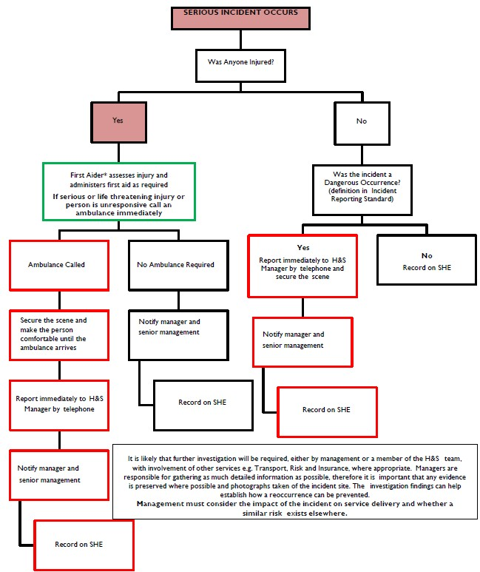
APPENDIX 2: INCIDENT INVESTIGATION REPORT TEMPLATE

Incident Investigation Report

SHE Reference: |  | HSE Reference
Incident Date |  | Investigation Date
Service |  | Work Location
Responsible Manager |  | Contact Number
Person in Control |  | Contact Number
Investigator/s |  | Contact Number

Third Party Interest: | HSE | Police | Fire Service | Risk & Insurance | SEPA | EHO

Supporting Documents | SHE Report | Witness Statements | Photos | RAMS | Inspection/ maintenance records | Training Records

Incident Detail
Where and when did the incident happen?
Give the exact location and time of incident.
What type of work task/ activity was being carried out at the time of the incident?
Who was involved in the incident?
Provide the names and designations of all persons involved, including any witnesses.
Were any injuries sustained as a result of the incident and was medical attention required? Name(s) of injured person, type of injury and nature of first aid/medical assistance. Specify if person(s) taken to hospital.
How did the incident happen?
Give a full description of the events leading up to and during the incident.

Was any plant or equipment which was in use at the time of the incident, in good condition and properly inspected/maintained?
Check inspection/ maintenance records where applicable.
Had the employees received appropriate information, instruction and training for the task/ activity being carried out?
Training/induction records where applicable.
Were there adequate safe working procedures in place for the tasks being carried out?
Appropriate risk assessments/ method statements etc.
Were the risks known to those involved in the incident?
Has the risks associated with the task/ activity been identified and communicated to those involved.
Did environmental issues influence the incident?
E.g. Lighting, heating, weather conditions, ground conditions etc.
Was appropriate Personal Protective Equipment (PPE) worn and in good condition?

INCIDENT ANALYSIS
Immediate Cause(s)
Unsafe act or unsafe conditions that led directly to the incident e.g. removal of machine guard, not wearing PPE, employee error, poor housekeeping, uneven ground conditions etc.
Underlying/Root Cause(s)
Inadequacies in the management of health and safety e.g. Poor maintenance of equipment, inadequate training/instruction, poor supervision, incomplete or missing risk assessments/safe systems of work etc.

Conclusions

Actions Required | Responsible Officer | Timescale

Incident Photographs

Report Distribution List
Name | Designation

APPENDIX 3: INCIDENT INVESTIGATION PROCESS
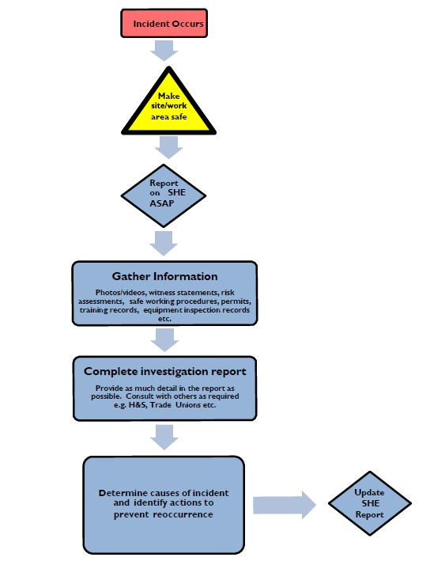
APPENDIX 4: INCIDENT DEBRIEF GUIDE FOR MANAGERS – VIOLENCE & AGRESSION

The purpose of this guide is to provide advice and assistance for managers in investigating and monitoring incidents of violence and aggression, reported via the SHE Incident Reporting System (SHE).

Encourage employees to report all incidents, including verbal or written abuse, and provide proportionate and sensitive support to them after the incident.

Employees often don’t report because they:

- Think dealing with aggressive customers is part of their day-to-day job
- Think that it will make them look incompetent or at fault for the incident
- Find the reporting process difficult
- Think that no action will be taken
- Will end up with more work/experience stress

Following the incident, if reported to the line manager verbally or via email, ensure the employee enters the information on the SHE system. If they are unsure how to report or need refresher training, further information including user guides and links to the Learn Pro module can be found on the intranet.

Incidents of violence and aggression can impact on people in different ways, such as:

- Self confidence
- Insomnia / nightmares / disturbed sleep
- Anger
- Anxiety
- Depression
- Guilt
- Difficulties completing or performing tasks
- Absenteeism
- Fear
- Feeling incompetent
- Increased use of alcohol, caffeine and/or medication
- Post-Traumatic Stress Disorder

The action required immediately following an incident will depend on the nature of the incident and how it has affected those involved.

In incidents of verbal abuse, for example, giving the employee the opportunity to discuss with a line manager or colleague and providing friendly support may be sufficient. The line manager should record this action in the SHE Incident Review.

In the event of a more serious incident, immediate actions would include:

- Ensuring those involved are safe and offered support, e.g. someone sitting with them, or staying on the phone/arranging someone to visit them if they are working alone
- Arranging any medical care that may be required
- Contacting the Police if required
- Securing the premises, and any evidence
- Be clear on who will take charge of dealing with the incident and related communications
- Ensure investigation and follow-up actions are undertaken

After the initial/immediate actions, offer employees, including those indirectly involved such as witnesses or colleagues, the opportunity to talk openly about the incident and how they are feeling with their line manager and colleagues, as appropriate, and provide them with constructive support. They may not be ready to talk at the time this is offered, so ensure they know they are able to have the discussions at a later date should they wish to. Some people may not want to talk about it at all, if this is the case, record on the SHE system that this support was offered.

It can take some time for the after effects of the incident to occur, so it is important to review incidents with the employee, have regular contact and offer them a safe space to raise any issues they are experiencing. Counselling can also be offered via the Employee Counselling Service – which can be arranged by a line manager or via self-referral. Additional or alternative supports can be found via the Trust’s Support & Wellbeing page with the Intranet and PAMS trauma support.

If an employee is particularly affected by an incident, it may be beneficial to discuss a review of their working arrangements, e.g. temporarily removing them from public facing duties, restrict contact from certain individuals (redirect them to other colleagues). Any proposed changes should be agreed with the employee and guidance sought from the Executive Lead: People, Policy & Performance, where appropriate, in order to ensure that they are not being exposed to situations which could trigger a stress response from the previous incident.

Upon notification via the SHE system, review the details and record any additional actions to mitigate a recurrence or to further protect the employees.

The employee should record any known supports, e.g. Housing Support, Health and Social Care Partnership for the individual responsible for the incident and record any referrals made to request support they may require. Individual factors, such as disabilities, known mental health issues, etc. should be taken into account when agreeing if any actions are required against the individual.

Ensure the relevant risk assessments are circulated to all employees and that following receipt, they confirm they have read and understood. Involve employees in the review of relevant risk assessments, to seek their input on the effectiveness of existing control measures.

Ensure health and safety and wellbeing are standing items on agendas for team meetings and one to ones and encourage employees to raise any concerns or issues with their line manager.

