

**AUTHORISED BY:** Chief Officer

**DATE:** September 2021

1. **OBJECTIVE AND SCOPE:**

Asbestos Management is one of a number of health and safety standards, forming the Trust’s Health and Safety Policy written arrangements in compliance with the general duties under the [Health and Safety at Work etc. Act 1974](http://www.legislation.gov.uk/ukpga/1974/37/contents). Any reference to the Council in this document will refer to East Ayrshire Council.

This standard relates specifically to the [Control of Asbestos Regulations 2012](http://www.legislation.gov.uk/uksi/2012/632/contents/made) and outlines the arrangements in place to protect employees and other persons; against the risk of exposure to asbestos containing materials in buildings that East Ayrshire Leisure has Premise Manager Responsibilities for.

1. **RESPONSIBILITY:**

Overall responsibility for this standard belongs to the Executive Managers and Development Managers. Persons with key responsibilities are Managers, Premises Managers, Officers, Co-ordinators and employees for ensuring duties are managing safety on a daily basis.

Staff with responsibilities for the management of buildings will be required to supplement this standard with written details of the local arrangements in place to manage the risks i.e. the asbestos register, which should be retained on site wherever practicable.

**CONTENTS**

**1** **INTRODUCTION 2**

**2** **WHAT IS ASBESTOS 2**

**3 RISKS ASSOCIATED WITH ASBESTOS 3**

**4 DUTIES & RESPONSIBILITES 3**

4.1 Chief Officer 3

4.2 Contract Administrator 4

4.3 Health & Safety Section 4

4.4 Asset Performance Team 4

4.5 Other persons with duties relating to the management of asbestos 4

4.6 Employees engaged in work around asbestos containing materials 5

**5 MANAGEMENT OF ASBESTOS 6**

5.1 Surveys and Sampling 6

5.2 Asbestos Register 6

5.3 Contractors 6

5.4 Provision of information 6

5.5 Premises leased from the Council 6

**6 FURTHER INFORMATION 7**

6.1 Contact Information 7

6.2 External source of information 7

**7 APPENDIX 1**

Sample asbestos register

**8 APPENDIX 2**

Asbestos register verification

**9 APPENDIX 3**

Guidance Note – Suspected exposure to asbestos in the workplace

**10 APPENDIX 4**

Guidance Note - Asbestos in public places

1. INTRODUCTION

1.1 The Trust will take all reasonably practicable steps to protect their employees and other persons who may be at risk, against the hazards arising from asbestos containing materials (ACMs) within the premises it manages.

1.2 Asbestos Management, has been developed to give comprehensive guidance to managers and employees who may encounter ACMs in the workplace.

1.3 In recognition of the potential health hazards of ACMs and to ensure compliance with the Control of Asbestos Regulations 2012 and approved Codes of Practice and guidance notes issued by the Health and Safety Executive (HSE); all asbestos related matters will be dealt with in accordance with the procedures set out in this document.

1.4 This Standard should therefore be communicated to all employees working with or around ACMs, in particular staff involved in the management, control or maintenance of property, including work on IT systems and those co-ordinating the activities of contractors.

# 2. WHAT IS ASBESTOS?

Asbestos is a naturally occurring fibrous material with unique properties that make it ideal for reinforcing many materials used in the manufacture of building products. Used throughout the construction of public, commercial and industrial buildings, it is used as an insulator, has good fire protection properties and protects against corrosion.

Asbestos is often mixed with other materials, so it can be difficult to know whether it is present without carrying out specialised surveys. However, buildings which were built before the year 2000 are likely to contain asbestos somewhere within the premises and it can commonly be found in:

* Ceiling and floor tiles
* Lagging used on pipes and boilers
* Sprayed and textured coatings
* Insulating board
* Gaskets and seals
* Soffits
* Corrugated roof sheets
* Roof felt

There are three main types of asbestos; all are dangerous carcinogens but brown and blue are more hazardous than white.

* Chrysotile (white)
* Amosite (brown)
* Crocidolite (blue)

It must be remembered that the colour itself is not a reliable indication of the type of asbestos, since the natural colour tends to change through age and reaction to heat. Analysis of samples within a laboratory is the only way to confirm the type of asbestos.

# 3. RISKS ASSOCIATED WITH ASBESTOS

Asbestos is only a risk to human health if asbestos fibres are released into the air and breathed into the lungs. Breathing in air containing asbestos fibres may lead to asbestos-related diseases, mainly cancers of the lungs and chest lining.

There is usually a long delay between first exposure to asbestos and the onset of disease, varying from 15 to 60 years. There is no cure for asbestos-related diseases.

The presence of asbestos within buildings does not, in itself, present a hazard if it is in good condition and is left undisturbed. Furthermore, asbestos is likely to be mixed with other substances and sealed with paint or encapsulated (enclosed) by other materials, which inhibits fibre release.

Surveys have shown that asbestos in good condition does not release hazardous fibres, unless it is subjected to disturbance or damage. Therefore the risk of exposure to breathable fibres from asbestos found in normal circumstances is low.

It is generally safer, especially where asbestos is located in a position which is unlikely to be disturbed, to just leave the material in situ; since there can often be a greater hazard created by removal. Containment of asbestos is achieved by sealing, painting and physical encapsulation.

Where damage to ACMs is found, immediate remedial treatment must be carried out, including removal where necessary. All asbestos remedial works will be carried out by a specialist contractor.

# 4. DUTIES AND RESPONSIBILITIES

## **4.1 Chief Officer**

The Chief Officer is, in conjunction with the Council, responsible for ensuring the health, safety and welfare of employees and for any other persons who may be affected by the operations or activities carried out in areas under their control. With regard to asbestos, the Chief Officer will ensure that:

* Necessary arrangements for the management and control of asbestos are in place
* Appropriate information, instruction and training is provided for employees
* Specialist technical expertise in relation to asbestos is made available, through specialist asbestos contractors and the Health and Safety Section

## **4.2 Contract Administrator**

The Health and Safety Manager of the Council has been appointed as the Contract Administrator and has overall responsibility for ensuring that the contracts for the management of analysis, sampling and removal of asbestos in buildings leased to the Trust are adhered to.

Acting as an impartial agent between the Client, i.e. the Council/the Trust and the Principal Contractors; the Health and Safety Manager will oversee all aspects of the contracts, including producing the contract specifications and tender documentation.

## **4.3 Health and Safety Section**

The Health and Safety Section of the Council will provide competent advice and assistance in all aspects of the management and control of asbestos.

Other duties include:

* Updating and maintaining the Modus AIMS database for Trust Premises and making asbestos registers available for East Ayrshire Leisure to access
* Liaising with contractors to arrange the uplift of fly-tipped asbestos containing materials
* Provision of expert advice and support to East Ayrshire Leisure on asbestos related matters
* Carrying out periodic site safety inspections

**4.4 Asset Performance Team**

The Asset Performance team have responsibility, in public buildings, for:

* Updating and maintaining the Property Portal
* Ensuring re-inspection surveys are carried out
* Updating and distribution of asbestos registers to Premises Managers
* Liaising with contractors to undertake removals and investigatory surveys

## **4.5 Other persons with duties relating to the management of asbestos**

Trust employees with duties relating to the management of venues on a daily basis will ensure any contractor visiting the venue to carry out work that may involve disturbance of such material reads and signs the Asbestos Register. Premises Managers, will ensure that anyone employed at a venue in a work capacity reads and signs the asbestos register.

East Ayrshire Leisure employees with duties relating to the management and control of operations or activities involving the possible disturbance of ACMs, i.e. Premises Managers, Managers, Officers or designated person will:

* Be appropriately trained to recognise where ACMs may be present
* Consult the asbestos register/Property Portal to check for any potential ACMs prior to organising, engaging in or allowing works liable to disturb the fabric of the building
* Ensure all contractors visiting the building sign the asbestos register and check for the presence of ACM’s priorto carrying out works
* Ensure any building refurbishment or maintenance work where asbestos may be encountered is not permitted to start until the area of work has been surveyed

**Arranging and co-ordinating building refurbishment or upgrade works.**

In order to ensure that asbestos management information is kept up-to-date **it is essential** that employees responsible for organising, arranging and co-ordinating building refurbishment or upgrade works inform the Councils Asset Performance Manager (Facilities and Property Management) and Health and Safety Section in the following circumstances:

* ACMs are removed or encapsulated as part of the works
* The layout of the building is materially changed e.g. existing rooms are subdivided or part of the building is demolished
* The property information identification plate for any room or area of the building is changed

When notified of changes the Asset Performance Manager and Health and Safety Section will ensure that the building’s asbestos management information system e.g. The Councils Property Portal is updated and a new asbestos register is created for the building.

## **4.6 Employees engaged in work around asbestos containing materials**

Employees carrying out work in locations where there are ACMs must:

* Undergo asbestos awareness training
* Check the asbestos register prior to carrying out works. Additional asbestos information is available through the property portal.
* Fully co-operate with the Council’s established safety procedures and any specific working methods, having due regard and attention for their own safety and that of others at all times.
* Immediately notify line management of any breaches in the established safety procedures or of any physical hazards/defects observed when working around ACM’s
* Stop work immediately in the event of an ACM being disturbed/ broken. Lock/close the area and report to line management who will notify the Health and Safety Section. (See Appendix 3)

**4.7 Specialist Term Contractors**

The Council has term contracts in place for asbestos surveying, sampling, analysis and monitoring with a UKAS accredited laboratory and asbestos removal/encapsulation and disposal services with a licensed asbestos removal contractor.

# 5. MANAGEMENT OF ASBESTOS

**5.1 Surveys and sampling**

The Council’s specialist term contractor will carry out all surveys to determine the location, form, type and condition of ACM’s, either known or presumed.

**5.2 Asbestos Register**

The Asbestos register will be provided by the Councils Asset Performance Team and must be available on site, both hard copy and electronically on the Property Portal.

**5.3 Contractors**

Prior to making any arrangements for a contractor to carry out any works on a building, the Premise Manager must first contact the Asset Performance Team to confirm if there is asbestos present, or if there is a requirement for a survey to be carried out.

**5.4 Provision of information**

All information held by the Trust in connection with ACMs in Trust venues is available to the Premise Managers, employees of the Council and the Trust, contractors employed by the Council and the Emergency Services.

It is essential that the asbestos register is referred to prior to any work being planned or carried out.

Any contractor who is likely to disturb ACMs when undertaking work in a non-domestic property must complete the Verification Form (Appendix 2) within the asbestos register to confirm that they are in receipt of ACM information either via the asbestos register or job specific asbestos survey.

The verification form should be witnessed by the person responsible for the building, usually the Premises Manager. Employees and any other groups likely to be affected by works involving removal or repair of ACMs will be informed before any significant works are carried out.

**5.5 Premises leased from the Council**

All venues managed by the Trust that are leased from the Council will be managed in line with the Trust’s asbestos management standards. The Council will be responsible for the selection, vetting and competence of any contractor chosen to carry out work in these premises.

**5.6 Contractors working with asbestos containing materials**

Work on ACMs will only be undertaken by licenced asbestos contractors.

**5.7 Provision of training**

If any employee disturbs or encounters material which they believe may be asbestos that is in a condition which it is felt may expose themselves or others to risk, they must follow the established Council Procedures as detailed in Appendices 3 and 4.

Asbestos awareness training can be organised through Organisational Development at the Learning Academy.

**5.7 Uncontrolled release of asbestos in occupied buildings**

Where a building which contains presumed or identified ACMs is the subject of uncontrolled disturbance such as breakage or damage to the ACM, the Premises Manager must notify their manager and the Council’s Health and Safety Section immediately.

Where presumed ACMs are disturbed, all potentially affected areas must be sealed off and further access prevented until the area has been passed fit for occupation. See Appendix 3

**6. FURTHER INFORMATION**

**6.1 Contact Information**

Health & Safety Strategy Group, East Ayrshire Leisure

Telephone: 01563 554057

E Mail: [EALHealthandSafety@eastayrshireleisure.com](mailto:EALHealthandSafety@eastayrshireleisure.com)

Intranet: [Health & Safety](https://leisurenet/admin-docs/health-safety/)

Health and Safety Section, East Ayrshire Council

Tel: 01563 554825

E Mail: healthandsafety@east-ayrshire.gov.uk

EAC Intranet[Health and Safety](http://eacintranet/Services/HealthandSafety/HealthandSafety.aspx)

**6.2 External Sources of Information**

Further useful information and guidance on the management of asbestos, can be found in a variety of widely available HSE guidance documents and information sheets, including:

Asbestos essentials

<http://www.hse.gov.uk/asbestos/essentials/index.htm>

Asbestos Surveyors Guide HSG 264 – Surveying, sampling and Assessment of

Asbestos Containing Materials:

<http://www.hse.gov.uk/pubns/priced/hsg264.pdf>

Advice on non-licensed work with asbestos

<http://www.hse.gov.uk/pubns/guidance/a0.pdf>

What to do if you uncover or damage materials that may contain asbestos

<http://www.hse.gov.uk/pubns/guidance/em1.pdf>

## **Appendix 1 – SAMPLE ASBESTOS REGISTER**



**Corporate Health and Safety Policy Arrangements**

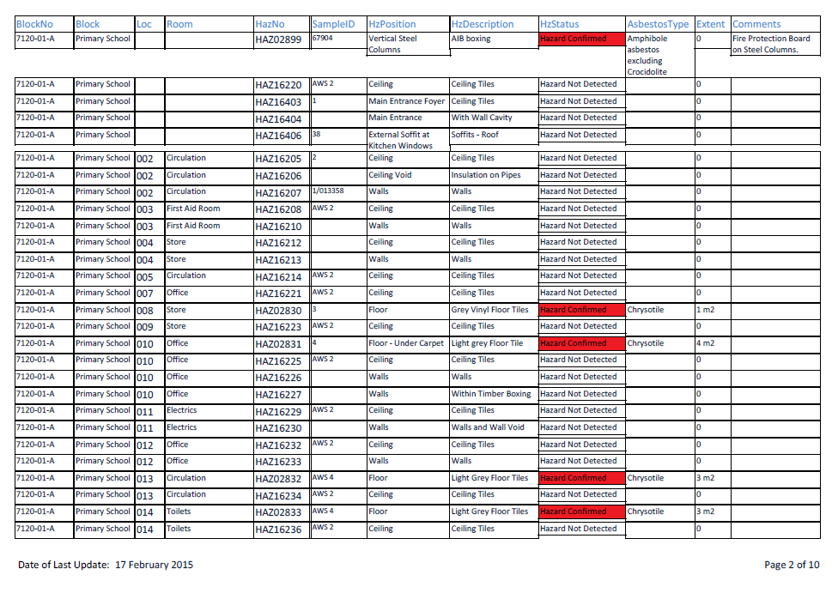

**Example**

Location 002 is a circulation area with ceiling tiles that have been sampled and **do not** contain asbestos.

Location 008 is a store with 1m2 of asbestos containing grey floor tiles.

## **Appendix 2 - ASBESTOS REGISTER VERIFICATION**

The asbestos register must be checked for all areas where work will be carried out.

All details to be entered in columns 1-5 by the Contractor.

Column 6 to be signed by the nominated responsible person for the building.

|  |  |  |  |  |  |
| --- | --- | --- | --- | --- | --- |
| **(1) Date** | **(2) Name (Please print)** | **(3) Company** | **(4) Location of Work**  **(list of areas)** | **(5) Nature of Work**  **(include Order number)** | **(6) Signature of Responsible Person** |
| **Signature** |
|  |  |  |  |  |  |
|  |
|  |  |  |  |  |  |
|  |
|  |  |  |  |  |  |
|  |
|  |  |  |  |  |  |

**Health and Safety Standard: Asbestos Management**

**Revision: 2018/Issue04**

## **Appendix 3 - GUIDANCE NOTE – SUSPECTED EXPOSURE TO ASBESTOS IN THE WORKPLACE**

If during any work operation there is disturbance or breakage of material which is suspected to contain asbestos, **the following flow diagram should be followed.**

**This includes any reported incidents of accidental disturbance of suspected asbestos containing materials by tenants in Council housing stock.**

The Health and Safety Manager will ensure the incident is investigated, confirming if exposure did occur and what action is required. Where possible exposure involves an employee, the incident should be recorded on SHE. The Head of Corporate Services and EAC Risk and Insurance Adviser must also be informed.

If there is dust or debris on hair, skin or clothing, wipe down with damp rags and shower as soon as possible.

Leave and close/ lock the area and keep all persons out – **DO NOT REMOVE ANY TOOLS, EQUIPMENT OR MATERIALS**

Put up warning sign – **POSSIBLE HAZARD DO NOT ENTER UNTIL FURTHER NOTICE**

Notify Line Manager and Health and Safety Section **immediately**

Discover or damage materials that could contain asbestos? **STOP WORK IMMEDIATELY**

Health and Safety Section/ Client Service will arrange for inspection / air tests to be carried out by the specialist contractor to confirm if area is safe for re-occupation.

Health and Safety Section/ Client Service will arrange for remedial works to be carried out by the Council’s Licenced Asbestos Removal Contractor if required.

## **Appendix 4 – ASBESTOS IN PUBLIC BUILDINGS**

If you encounter damaged components within a building, consideration must be given to whether they may contain asbestos before any clean-up work is carried out.

Asbestos can be found in a number of locations in public buildings constructed before the year 2000. The most common areas where it is found inside EAC buildings are:

* Ceilings
  + Textured coatings (artex)
  + Ceiling tiles (cement panels or asbestos insulating board)
* Flooring
  + Floor tiles
  + Vinyl flooring
  + Paper backed tiles
* Walls and doors
  + Cement panels
  + Door panels (interior and exterior)
  + Insulating board panels
  + Textured coating (artex)
* Pipework
  + Insulation / lagging
* Other
  + Panels behind storage heaters
  + Sink pads
  + External soffits

In buildings constructed pre 2000, identified asbestos containing materials are detailed in the Asbestos Register for the building, which is usually held by the janitor, caretaker or premises manager.

Any items which contain or are suspected to contain asbestos and are in good condition do not pose any risk. If, however, they become damaged, for example due to a water leak and ceiling collapse, **the procedure below must be followed.**

**POTENTIAL UNCONTROLLED ASBESTOS FIBRE RELEASE**

Close Case

Review Case with H&S

Make Good Damages

Arrange Removal/Encapsulate

No

Yes

Positive for ACMs

Direct Sample Suspected ACMs

F&PM Instruct Air test

Notify F&PM Helpdesk & H&S

Secure Room, put up Signage

Signage suggestion:

Potential Hazard do not enter until further notice

Put tape across entrance if door cannot be locked

Yes

No

**Check Asbestos Register**

Building fabric damaged e.g. collapsed tile, debris on floor etc.

Known/ Suspected ACMs