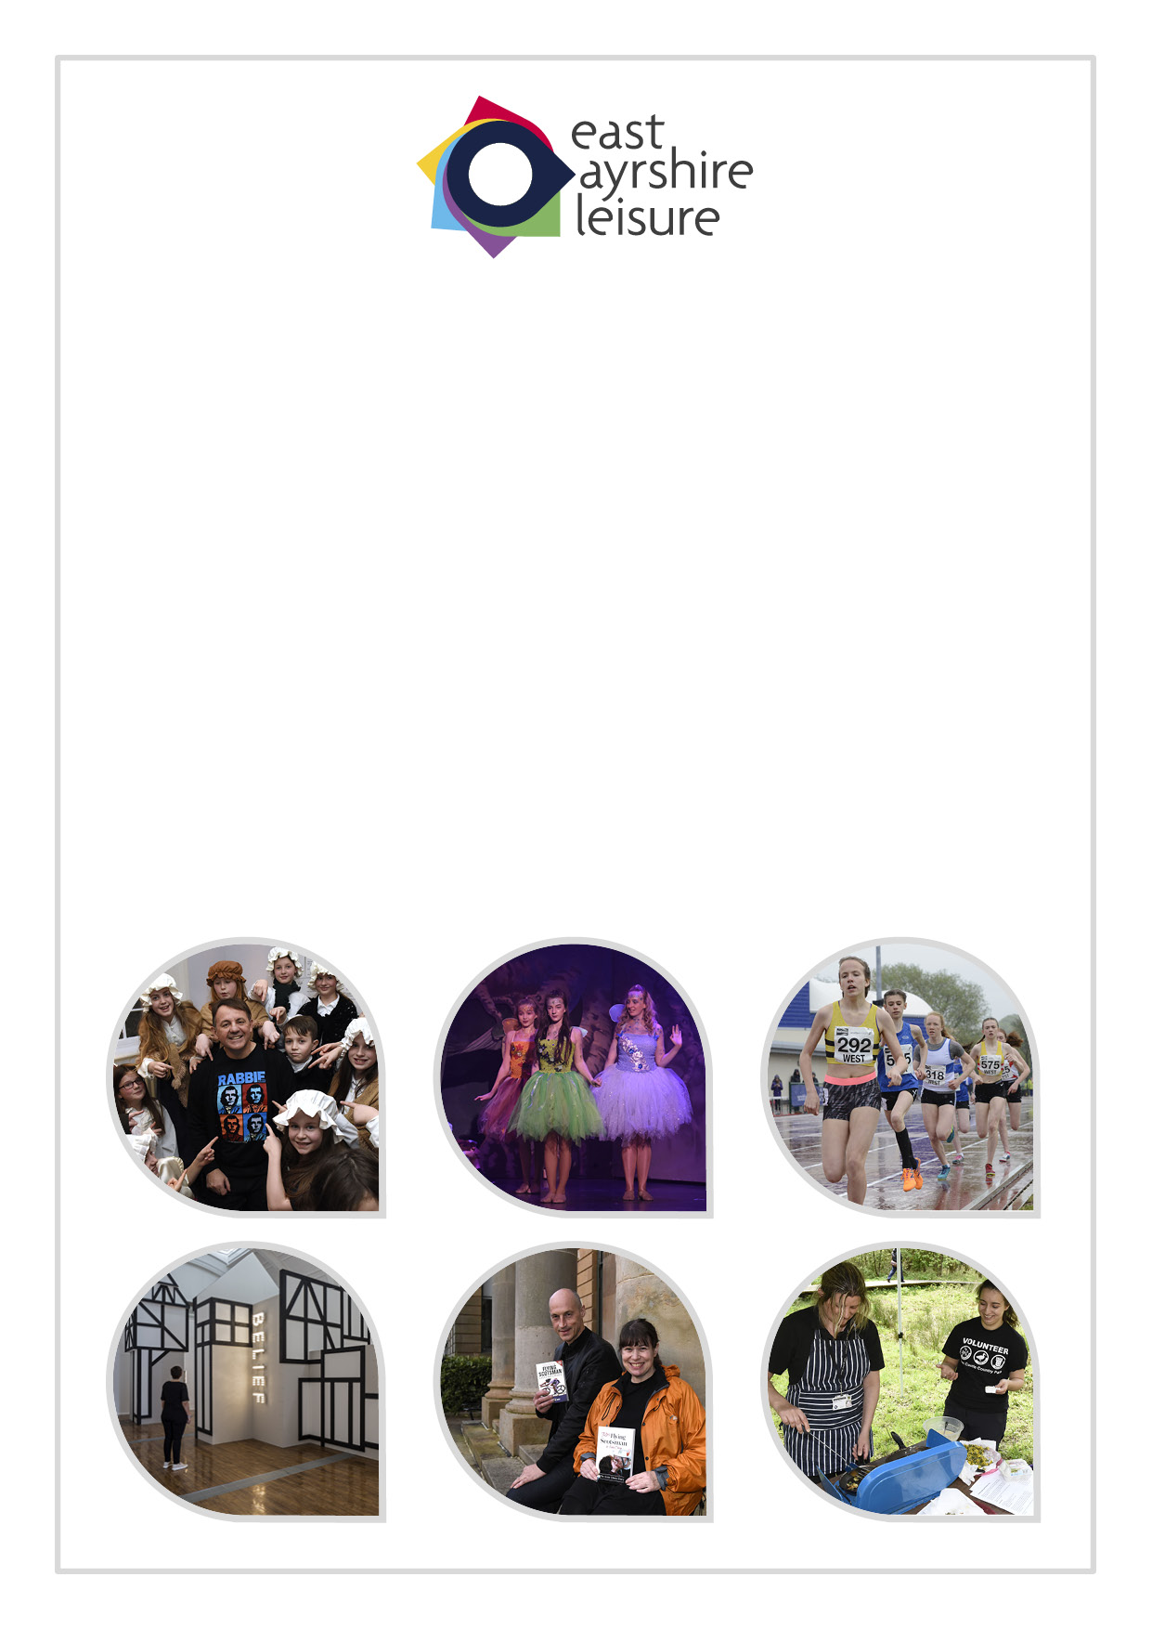
Direct Marketing Policy

Privacy & Electronic Communications Regulations (PECR)

Contents
Page
Introduction 3
Overview 3
Data Protection Act 4
Privacy and Electronic Communications Regulations 4
ICO enforcement 4
The definition of direct marketing 5
Market research and ‘sugging’ 5
Solicited and unsolicited marketing 6
Consent 6
Marketing calls 8
Marketing texts and emails 9
Marketing online 10
Marketing mail 10
Lead generation and marketing lists 10
In-house marketing lists 10
Suppression 11
Contacts 11

Appendix 1
ICO Direct Marketing Checklist

Introduction

The Data Protection Act 1998 (the DPA) is based around eight principles of good information handling. These give people specific rights in relation to their personal information and place certain obligations on those organisations that are responsible for processing it. Please read East Ayrshire Council’s suite of documents, in particular ‘Data Protection Guidance to Staff’ for further information (available on the Intranet).

The Privacy and Electronic Communications Regulations 2003 (PECR) provide rules about sending marketing and advertising by electronic means, such as by telephone, fax, email, text and picture or video message, or by using an automated calling system. PECR also include other rules relating to cookies, telephone directories, traffic data, location data and security breaches. The full document is available from the Marketing & Development team, however, this paper summarises the key points relevant to East Ayrshire Leisure.

The Information Commissioner’s Office (ICO) have also published a separate direct marketing checklist (Appendix 1) to help organisations comply with the law and good practice.

Overview (key points)
- Direct marketing covers the promotion of aims and ideals as well as the sale of products and services.
- Organisations will need consent to send people marketing, or to pass their details on. Organisations will need to be able to demonstrate that consent was knowingly and freely given, clear and specific, and should keep clear records of consent. The ICO recommends that opt-in boxes are used.
- The rules on calls, texts and emails are stricter than those on mail marketing, and consent must be more specific. Organisations should not take a one-size-fits-all approach.
- Organisations must not send marketing texts or emails to individuals without their specific prior consent.
- Organisations must stop sending marketing messages to any person who objects or opts out of receiving them.
- The ICO will consider using its enforcement powers, including the power to issue a fine, where an organisation persistently ignores individuals’ objections to marketing or otherwise fails to comply with the law.
- The direct marketing checklist can help organisations to comply.

Data Protection Act
If direct marketing involves the processing of personal data (in simple terms, if the organisation knows the name of the person it is contacting), it must comply with the principles set out in the DPA. The most relevant principles in this context are:

- Organisations must process personal data fairly and lawfully. In particular, they will usually need to tell the individuals concerned who they are and that they plan to use those details for marketing purposes. Organisations will also need to tell people if they plan to pass those details on to anyone else, including selling or sharing the data for marketing purposes
- Organisations must only collect personal data for specified purposes, and cannot later decide to use it for other ‘incompatible’ purposes. They cannot use people’s details for marketing purposes if they originally collected them for an entirely different purpose.
- Organisations must ensure that personal data is accurate and, where necessary, kept up to date. So a marketing list which is out of date, or which does not accurately record people’s marketing preferences, could breach the DPA.

The DPA also outlines that an individual can, at any time, give written notice to stop using their details for direct marketing. It is good practice to acknowledge the request and confirm that the marketing will stop. The ICO expect that calls, texts or other electronic communications should stop within 28 days of receiving the objection, and postal communications should stop within two months.

Privacy and Electronic Communications Regulations
PECR were designed to complement the DPA. In very broad terms, PECR outlines that an organisation cannot send texts or emails to individuals without their specific consent.
An organisation must always say who it is. It also has to provide contact details, so that an individual can make contact if they want to opt out of the marketing.

ICO enforcement
The ICO can take enforcement action wherever the law relating to direct marketing is not being complied with. The ICO can also impose large fines for a serious breach. They are most likely to take such action where an organisation persistently ignores people’s objections to marketing calls or texts, sends mass texts without consent, or fails to screen its call list against the Telecom Protection Service (TPS).

Examples of where fines have been imposed:
Sending marketing emails without consent:
- Telegraph Media Group Ltd - £30,000

Sending marketing text messages without consent;
- Parklife Manchester Ltd - £70,000

The definition of direct marketing
The DPA defines “direct marketing” as “the communication (by whatever means) of any advertising or marketing material which is directed to particular individuals”.

It also covers any messages which include some marketing elements, even if that is not their main purpose. The key element of the definition is that the material must be directed to particular individuals. Indiscriminate blanket marketing – for example, leaflets delivered to every house in an area, magazine inserts, or adverts shown to every person who views a website – will not therefore fall within this definition of direct marketing.

Market research and ‘sugging’
The direct marketing rules will not apply if an organisation contacts customers to conduct genuine market research (for example the purpose is to use market research to make decisions for commercial or public policy) or contracts a research firm to do so, as this will not involve the communication of advertising or marketing material.

However, an organisation cannot avoid the direct marketing rules by labelling its message as a survey if it is actually trying to sell goods or services. This is sometimes referred to as ‘sugging’ (selling under the guise of research). If the call or message includes any promotional material, or collects data to use in future marketing exercises, the call or message will be for direct marketing purposes.

If an organisation claims it is simply conducting a survey when its real purpose (or one of its purposes) is to sell goods or services, generate leads, or collect data for marketing purposes, it will be breaching the DPA when it processes the data.

If during a genuine market research project an organisation discovers errors in its customer database, ICO consider it can use the research data to correct these errors without breaching the DPA or PECR.
Direct marketing is not limited to advertising goods or services for sale. It also includes promoting an organisation’s aims and ideals.

Not-for-profit organisations such as East Ayrshire Leisure therefore need to ensure that they clearly and prominently explain to supporters what their details will be used for and obtain clear, specific consent for electronic marketing. They should take particular care when communicating by text or email; they will not be able to send campaigning texts or emails without specific consent, even to existing supporters.

Example:
An individual sees a charity appeal in a newspaper and decides to donate £5 by text message. However the fact that the individual has decided to donate on this occasion (and provided their number to the charity as a result) does not mean that the charity has their consent to use their details to contact them about future campaigns. The charity cannot therefore use the individual’s details for marketing purposes.

Solicited and unsolicited marketing
There is no restriction on sending solicited marketing – that is, marketing material that the person has specifically requested. If the marketing has not been specifically requested, it will be unsolicited and the PECR rules apply. This is true even if the customer has ‘opted in’ to receiving marketing from that organisation.

Example:
When he requested the quote, the customer also ticked a box opting in to receiving information about future home improvement offers. A few months later, the company sends an email with details of a new offer. This is unsolicited marketing, because the customer did not contact the company to specifically request information about that particular offer.

Consent
Consent is central to the rules on direct marketing. If organisations cannot demonstrate that they had valid consent, they may be subject to enforcement action.

To be valid, consent must be knowingly and freely given, clear and specific. Organisations should keep clear records of what an individual has consented to, and when and how this consent was obtained, so that they can demonstrate compliance in the event of a complaint.
The key points are that for consent to be valid, it must be:
- freely given – the individual must have a genuine choice over whether or not to consent to marketing. Organisations should not coerce or unduly incentivise people to consent,
- specific – in the context of direct marketing, consent must be specific to the type of marketing communication in question (e.g. automated call or text message)
- informed – the person must understand what they are consenting to. Organisations must make sure they clearly and prominently explain exactly what the person is agreeing to, if this is not obvious.

We cannot assume consent from non-response to an email, as this would not be a positive indication of agreement.

Example:
A company decides that it wants to use its customer database to market individuals. The customers have not previously consented to receiving marketing messages so the company sends a letter to customers stating that it intends to send them details of special offers by post and email. The letter provides a number for customers to call if they don’t want to receive marketing. Non-response does not constitute valid consent for marketing. Failure to call the number to opt-out will not satisfy the requirement that individuals provide an indication signifying agreement. The company will not therefore be able to market its customers on this basis.

Consent to receive phone calls cannot be extended to cover texts or emails, and vice versa. And a general statement of consent to receive marketing might be valid for mail marketing, but will not cover calls or texts.

Implied consent
The ICO recommends that organisations do not make consent to marketing a condition of subscribing to a service unless they can clearly demonstrate how consent to marketing is necessary for the service and why consent cannot be sought separately. It is recommended that organisations use opt-in boxes in order to obtain explicit consent.

Methods of obtaining consent
The clearest way of obtaining consent is to invite the customer to tick an opt-in box confirming that they wish to receive marketing messages via specific channels (e.g. post, email, live phone call etc).
There must be some form of communication or positive action by which the individual clearly and knowingly indicates their agreement. This might involve clicking an icon, sending an email, subscribing to a service, or providing oral confirmation.

Indirect (third party consent)
The customer must have anticipated that their details would be passed to the organisation in question, and that they were consenting to messages from that organisation. This will depend on what exactly they were told when consent was obtained.

Time limits
If an organisation is making contact by phone, text or email for the first time, the ICO recommend that it does not to rely on any indirect consent given more than six months ago – even if the consent did clearly cover that organisation. However, they accept there may be some very specific cases where the circumstances clearly indicate that the person would expect to start receiving marketing at a certain later date.

Proof of consent
If someone claims that they did not consent to receive an organisation’s marketing messages, that organisation may be at risk of enforcement action unless it can demonstrate that the person did give valid consent.

Organisations should therefore make sure that they keep clear records of exactly what someone has consented to. In particular, they should record the date of consent, the method of consent, who obtained consent, and exactly what information was provided to the person consenting.

Marketing calls
Fairness
The customer should be aware that the organisation has their number and plans to use it for marketing purposes. The organisation must not make any calls that the person would not reasonably expect.
Organisations should not make it difficult to opt out, for example by asking customers to complete a form or confirm in writing. As soon as a customer has clearly said that they don’t want the calls, they must stop.

If a customer objects or opts out at any time, their details should be suppressed as soon as possible. It is important not to simply delete their details entirely, otherwise there is no way of ensuring that the organisation does not call them again (see ‘Suppression’ section)

Marketing texts and emails
General rule: only with consent
Organisations can generally only send marketing texts or emails to individuals (including sole traders and some partnerships) if that person has specifically consented to receiving them.
The rules also apply to viral marketing – organisations will still need consent even if they do not send the messages themselves, but instead instigate others to send or forward them.

Organisations must not disguise or conceal their identity in any marketing texts or emails, and must provide a valid contact address for individuals to opt out or unsubscribe (which would mean consent was withdrawn). It is good practice to allow individuals to reply directly to the message and opt out that way, to provide a clear and operational unsubscribe link in emails or at least to provide a freephone number.

The right to opt out
Organisations must give the customer the chance to opt out at any time – both when they first collect the details, and in every email or text. Organisations should not assume that all customers will be happy to get marketing texts or emails in future. It must be simple to opt out. When first collecting a customer’s details, this should be part of the same process (e.g. online forms should include a prominent opt-out box, and staff taking down details in person should specifically offer an opt-out). In subsequent messages, ICO consider that the individual should be able to reply directly to the message, or click a clear ‘unsubscribe’ link.

Organisations must not send marketing texts or emails to an individual who has said they do not want to receive them. Organisations must comply with any written objections promptly to comply with the DPA – but even if there is no written objection, as soon as an individual says they don’t want the texts or emails, they must stop.

Customer details should be suppressed from marketing lists as soon as possible. It is important not to simply delete their details entirely, otherwise there is no way of ensuring that the organisation does not contact them again. See the section on suppression below.

Marketing online
Organisations must comply with the DPA if they are targeting online adverts at individual users using their personal data – which might apply if, for example, they display personalised adverts based on browsing history, purchase history, or log-in information. However, non-targeted marketing (i.e. the same marketing displayed to every user) or contextual marketing (i.e. targeted to the content of the page itself rather than the identity or characteristics of users) is unlikely to be subject to the DPA.

Marketing mail
PECR does not cover marketing by mail, but organisations sending marketing mail to named individuals must comply with the DPA. If an organisation knows the name of the person it is mailing, it cannot avoid DPA obligations by simply addressing the mail to ‘the occupier’, as it is still processing that individual’s personal data behind the scenes.

Lead generation and marketing lists
Marketing lists can be compiled in different ways, and vary widely in quality. A good marketing list will be up to date, accurate, and reliably record specific consent for marketing. A list like this can be used in compliance with the law and should generate few – if any – complaints. However, other lists may be out of date, inaccurate, and contain details of people who have not consented to their information being used or disclosed for marketing purposes. Using such a list is likely to result in a breach of both the DPA and PECR.

In-house marketing lists
Organisations might want to compile their own in-house marketing list of people who have bought goods or services in the past, or who have registered on a website or made an enquiry. They can do so, but should ensure they use these details fairly, and must make it clear that they intend to use the details for marketing. Organisations should not assume that an individual consents to marketing just because they have provided their details.
Organisations should also keep a copy of the information provided to the customer, and record when and how they obtained any consent. They should specifically record whether they have consent for texts, emails and automated calls.

Within East Ayrshire Leisure, the Marketing & Development Department hold all mailing lists in addition to those held within the Box Office and Booking system. Individual departments should not hold mailing lists for the purposes of direct marketing to customers. Please contact the team if you are looking for emails to be sent directly to customers.
Suppression
Organisations should maintain a ‘suppression list’ of people who have opted out or otherwise told that organisation directly that they do not want to receive marketing.
Individuals may ask an organisation to remove or delete their details from a database or marketing list. However, in most cases organisations should instead follow the marketing industry practice of suppressing their details. Rather than deleting an individual’s details entirely, suppression involves retaining just enough information to ensure that their preferences are respected in the future.
Suppression allows organisations to ensure that they do not send marketing to people who have previously asked them not to, as there is a record against which to screen any new marketing lists. If people’s details are deleted entirely, there is no way of ensuring that they are not put back on the database.
Deleting details might also breach industry-specific legal requirements about how long to hold personal data.

As the Marketing & Development Department hold all mailing lists in addition to those held within the Box Office and Booking system, they should be notified as soon as a customer request to be removed from the mailing list.

Contacts for enquiries:
Further details on any issues relating to Direct Marketing can be obtained from East Ayrshire Leisure’s Marketing & Development Department.
Dianne Reid Louise Kyle
Marketing & Development Manager Marketing Officer
t: 01563 554331 t: 01563 554330
e: dianne.reid@east-ayrshire.gov.uk e: louise.Kyle@east-ayrshire.gov.uk

Carol Keohone
Marketing Co-ordinator
t: 01563 554335
ee: carol.keohone@east-ayrshire.gov.uk
For further details on any issues relating to the Data Protection Act and Information Governance, please contact:
Robert Gibson
Information Governance Officer
Democratic Services
t: 01563 576094
e: robert.gibson@east-ayrshire.gov.uk

Record of Change:

Date reviewed | Date of next review
Nov 16 | Nov 19

