Information available for Trustees on
eastayrshireleisure.com
WEBSITE
www.eastayrshireleisure.com has a wealth of information from news items, venue opening hours and contact details, to tourist information, ‘what’s on’ guides and information on how to work for us. This document provides a brief overview on the key information most relevant to Trustees.

Home Page:
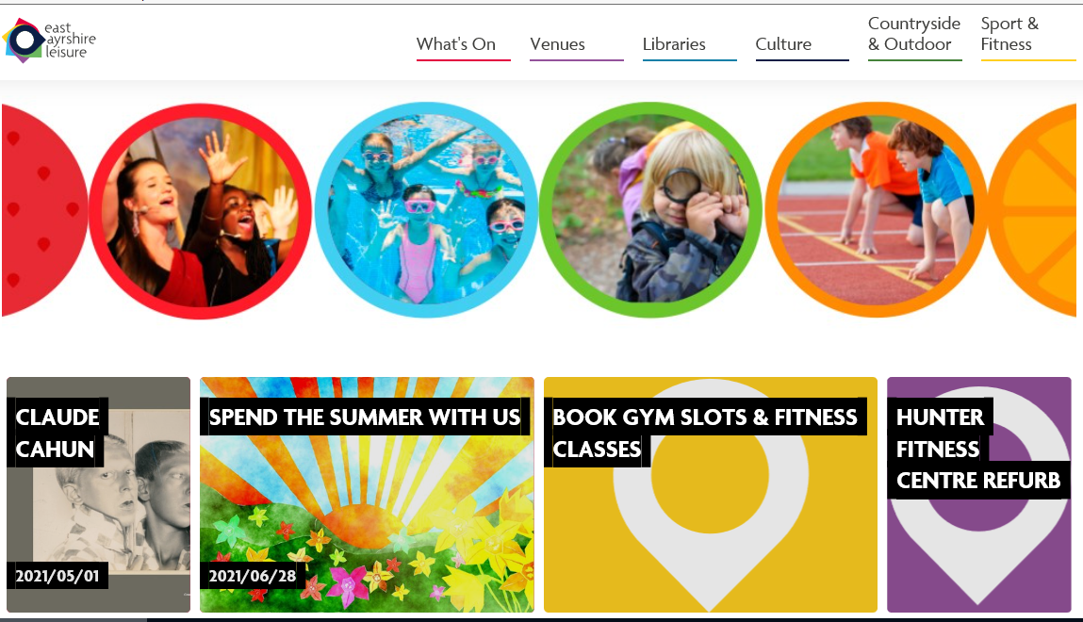

Venue Information:
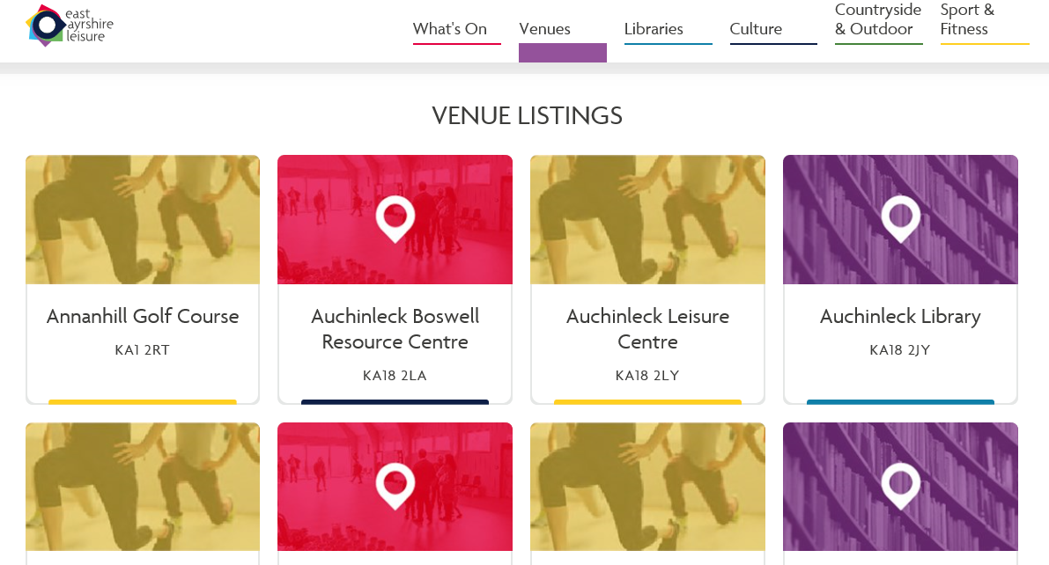
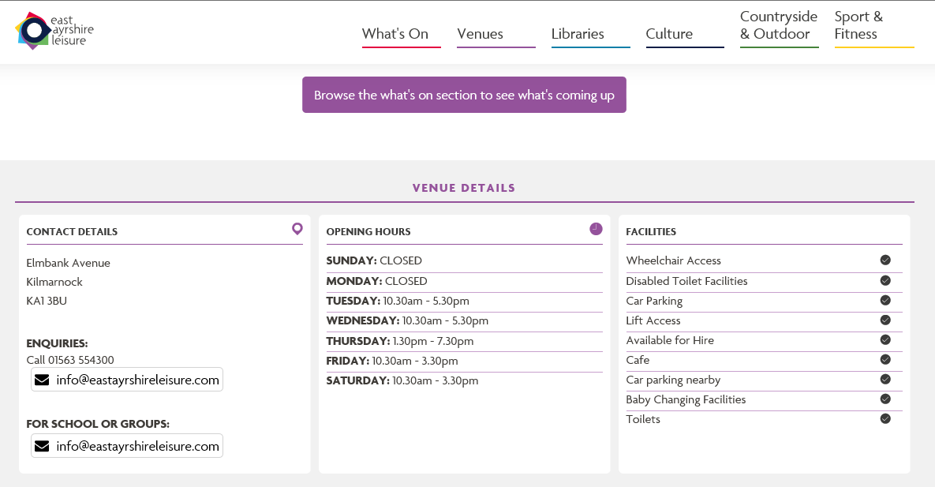
Example of Venue detail page, when you click on ‘Venues’ tab:

About Us & Document Library
We also publish a wealth of information and key documents on our website and these can be found within the ‘Document Library’ of the ‘About Us’ section.
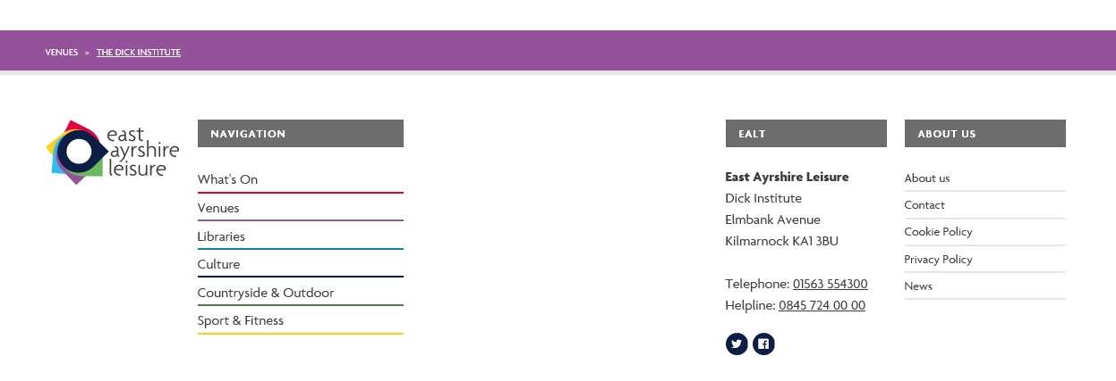
From the home page, scroll to the very bottom of the screen where you will see this:

Click on About Us at the bottom right of the screen.
Then scroll to the bottom of the screen until you see this banner:

If you can’t see the section you are looking for, the navigation arrows to the right and left will move the category boxes along.
Clicking on The Board, takes visitors to a contact form where they can send messages to our Trustees via a central mailbox.

Scrolling to the bottom of this page allows visitors to see biog information on all our Trustees.
Also within this section is our Document Library.

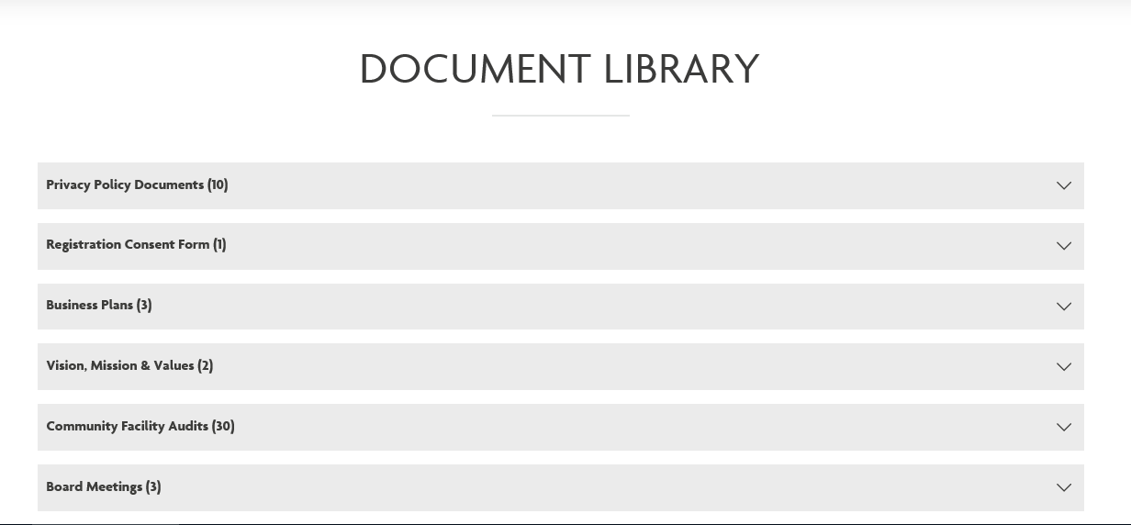
Clicking on this Document Library box will bring up this menu:

Clicking On Board Meetings will give access to Agendas & Reports, Minutes and AGM, all sub-categorised further by year.

Performance & Audit sub Committee papers, Annual Performance Reports, Annual Accounts can all be accessed from this top menu too.
Within the Trustee Documents section you can access Finance and HR Policies, Health & Safety Standards and Health & Safety Reports. Within Useful Documents you will be able to access the Trustee Information Pack and our Strategic Vision document.
