Trustee Learn Pro Instructions
LEARN PRO
When accessing Learn Pro for the first time from a council networked computer, simply click and open the link following link: LearnPro
The following box will appear, click on ‘CREATE ACCOUNT’
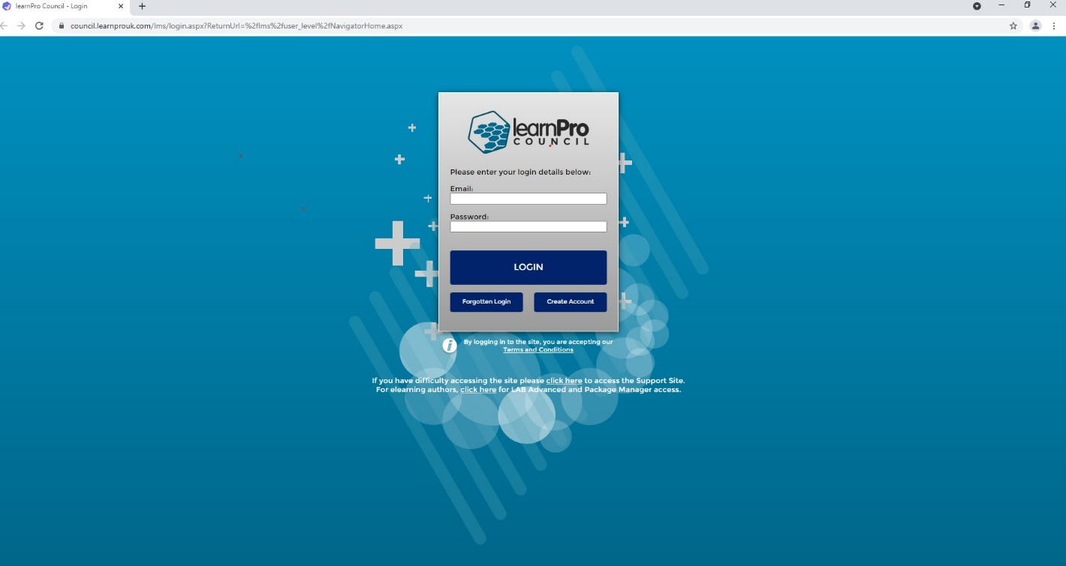
You will then be taken to the Terms and Conditions, once you have read through them, click ‘I AGREE TO THE TERMS AND CONDITIONS’
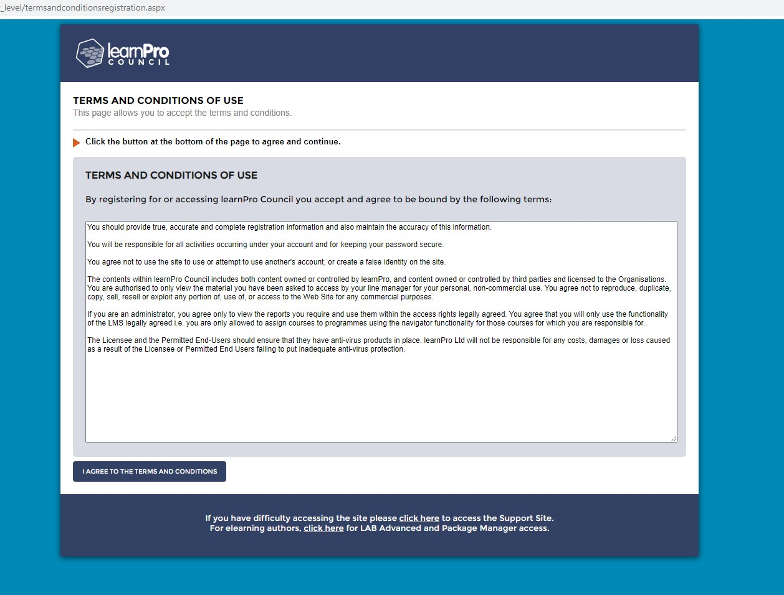
You will now be taken to the Registration process, click ‘CHOOSE FROM LIST’ and select SCOTLAND.
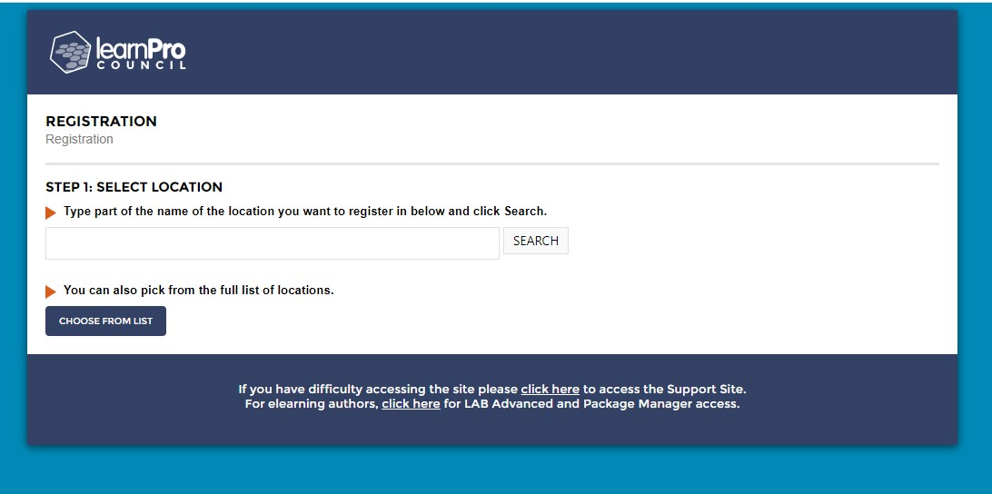

Select ‘EAST AYRSHIRE COUNCIL’
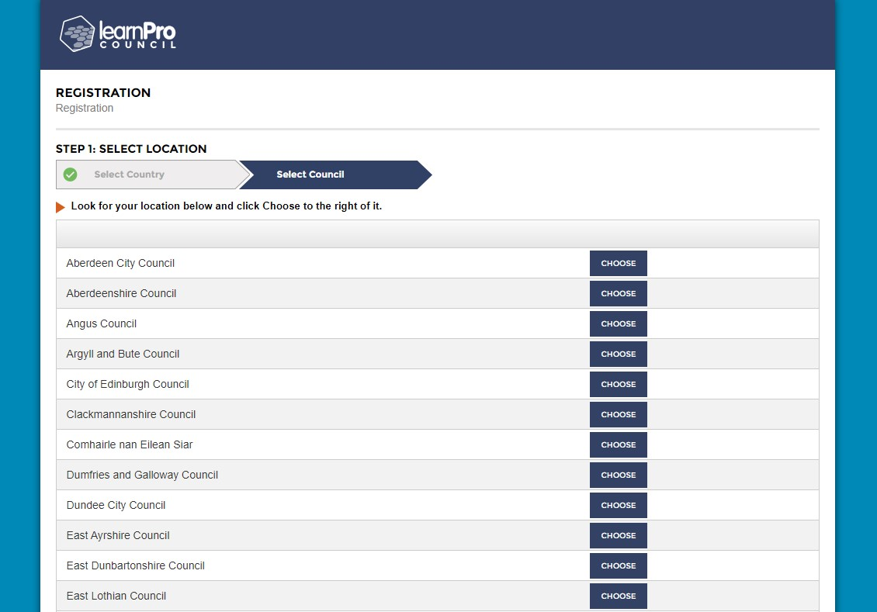

Now select ‘EAST AYRSHIRE LEISURE’
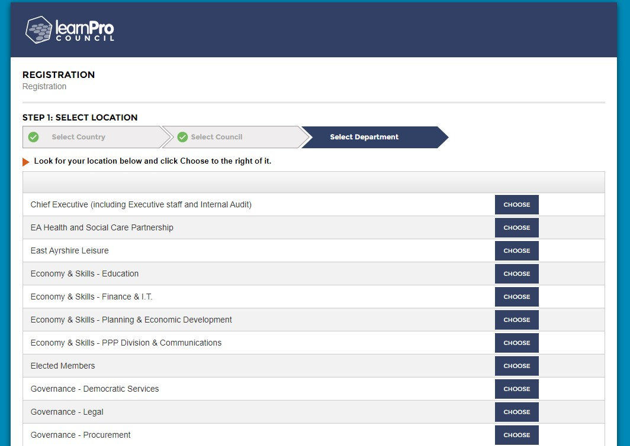

Select ‘CORPORATE SERVICES’
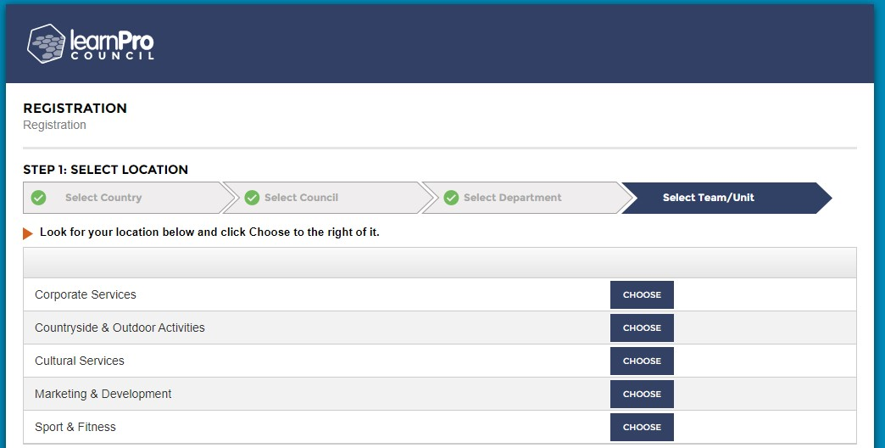

Click ‘CONFIRM AND CONTINUE’
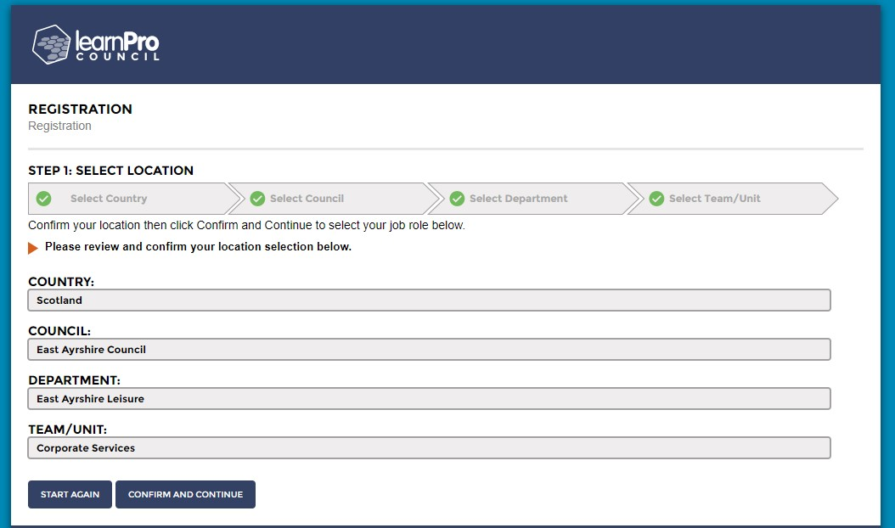

Type ‘Trustee’ as your job role and click ‘SEARCH’
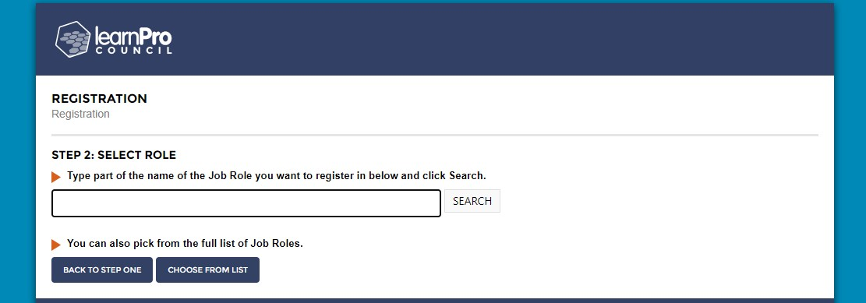

‘Trustee - East Ayrshire Leisure, East Ayrshire Council’ will appear in the box, select ‘CHOOSE’
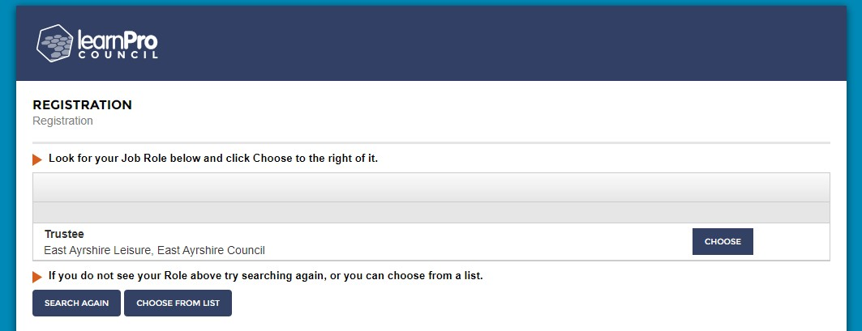

Once the following box appears, select ‘CONFIRM AND CONTINUE’

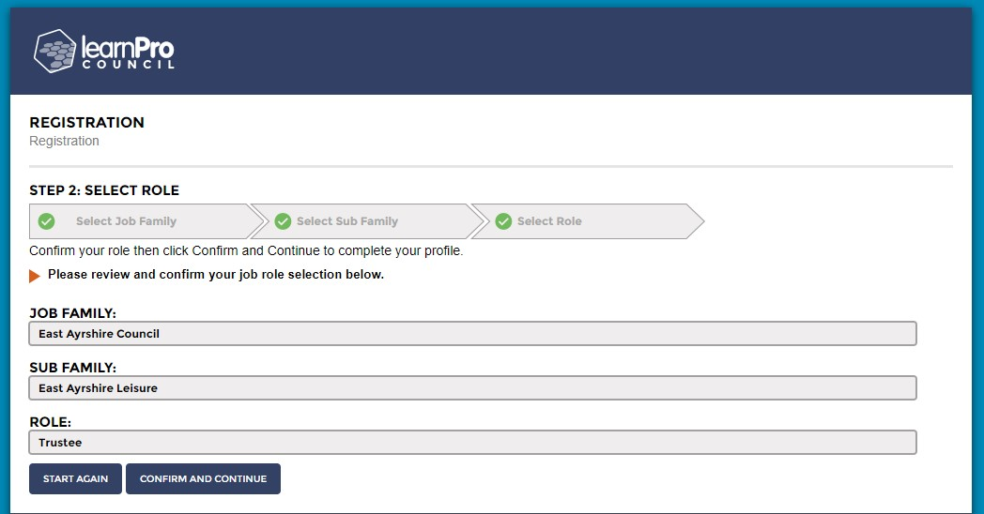

Finally, add in your personal details and create a password (please keep your password in a safe and secure location for future use)
Select ‘NEXT’ Your registration is now complete.
* Please note, if you are asked to supply an employee number, as a Trustee you are not required to have one, therefore can you create a dummy one with 7 numbers. You should then be able to gain access.
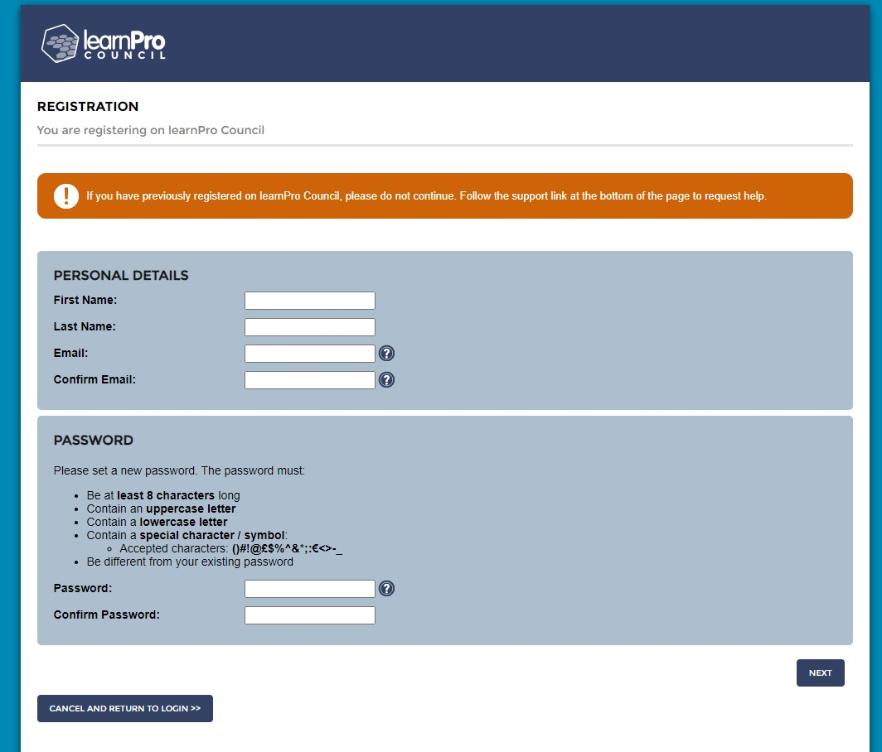
You will then have access to the training courses, the following mandatory trianing courses should be completed and can be found under the following categories:

Employee Essentionals
- Equality & Diversity
- Data Protection
- Information Security
- Records Management
- Suicide Awareness: Ask, Tell, Save a Life

Role Specific
- Cyber Awareness 2021

Core Skills
- Freedom of Information

